REPORT

REPORT
Generated on: Fri April 24, 2026 23:25:15

Login Process
Login Data
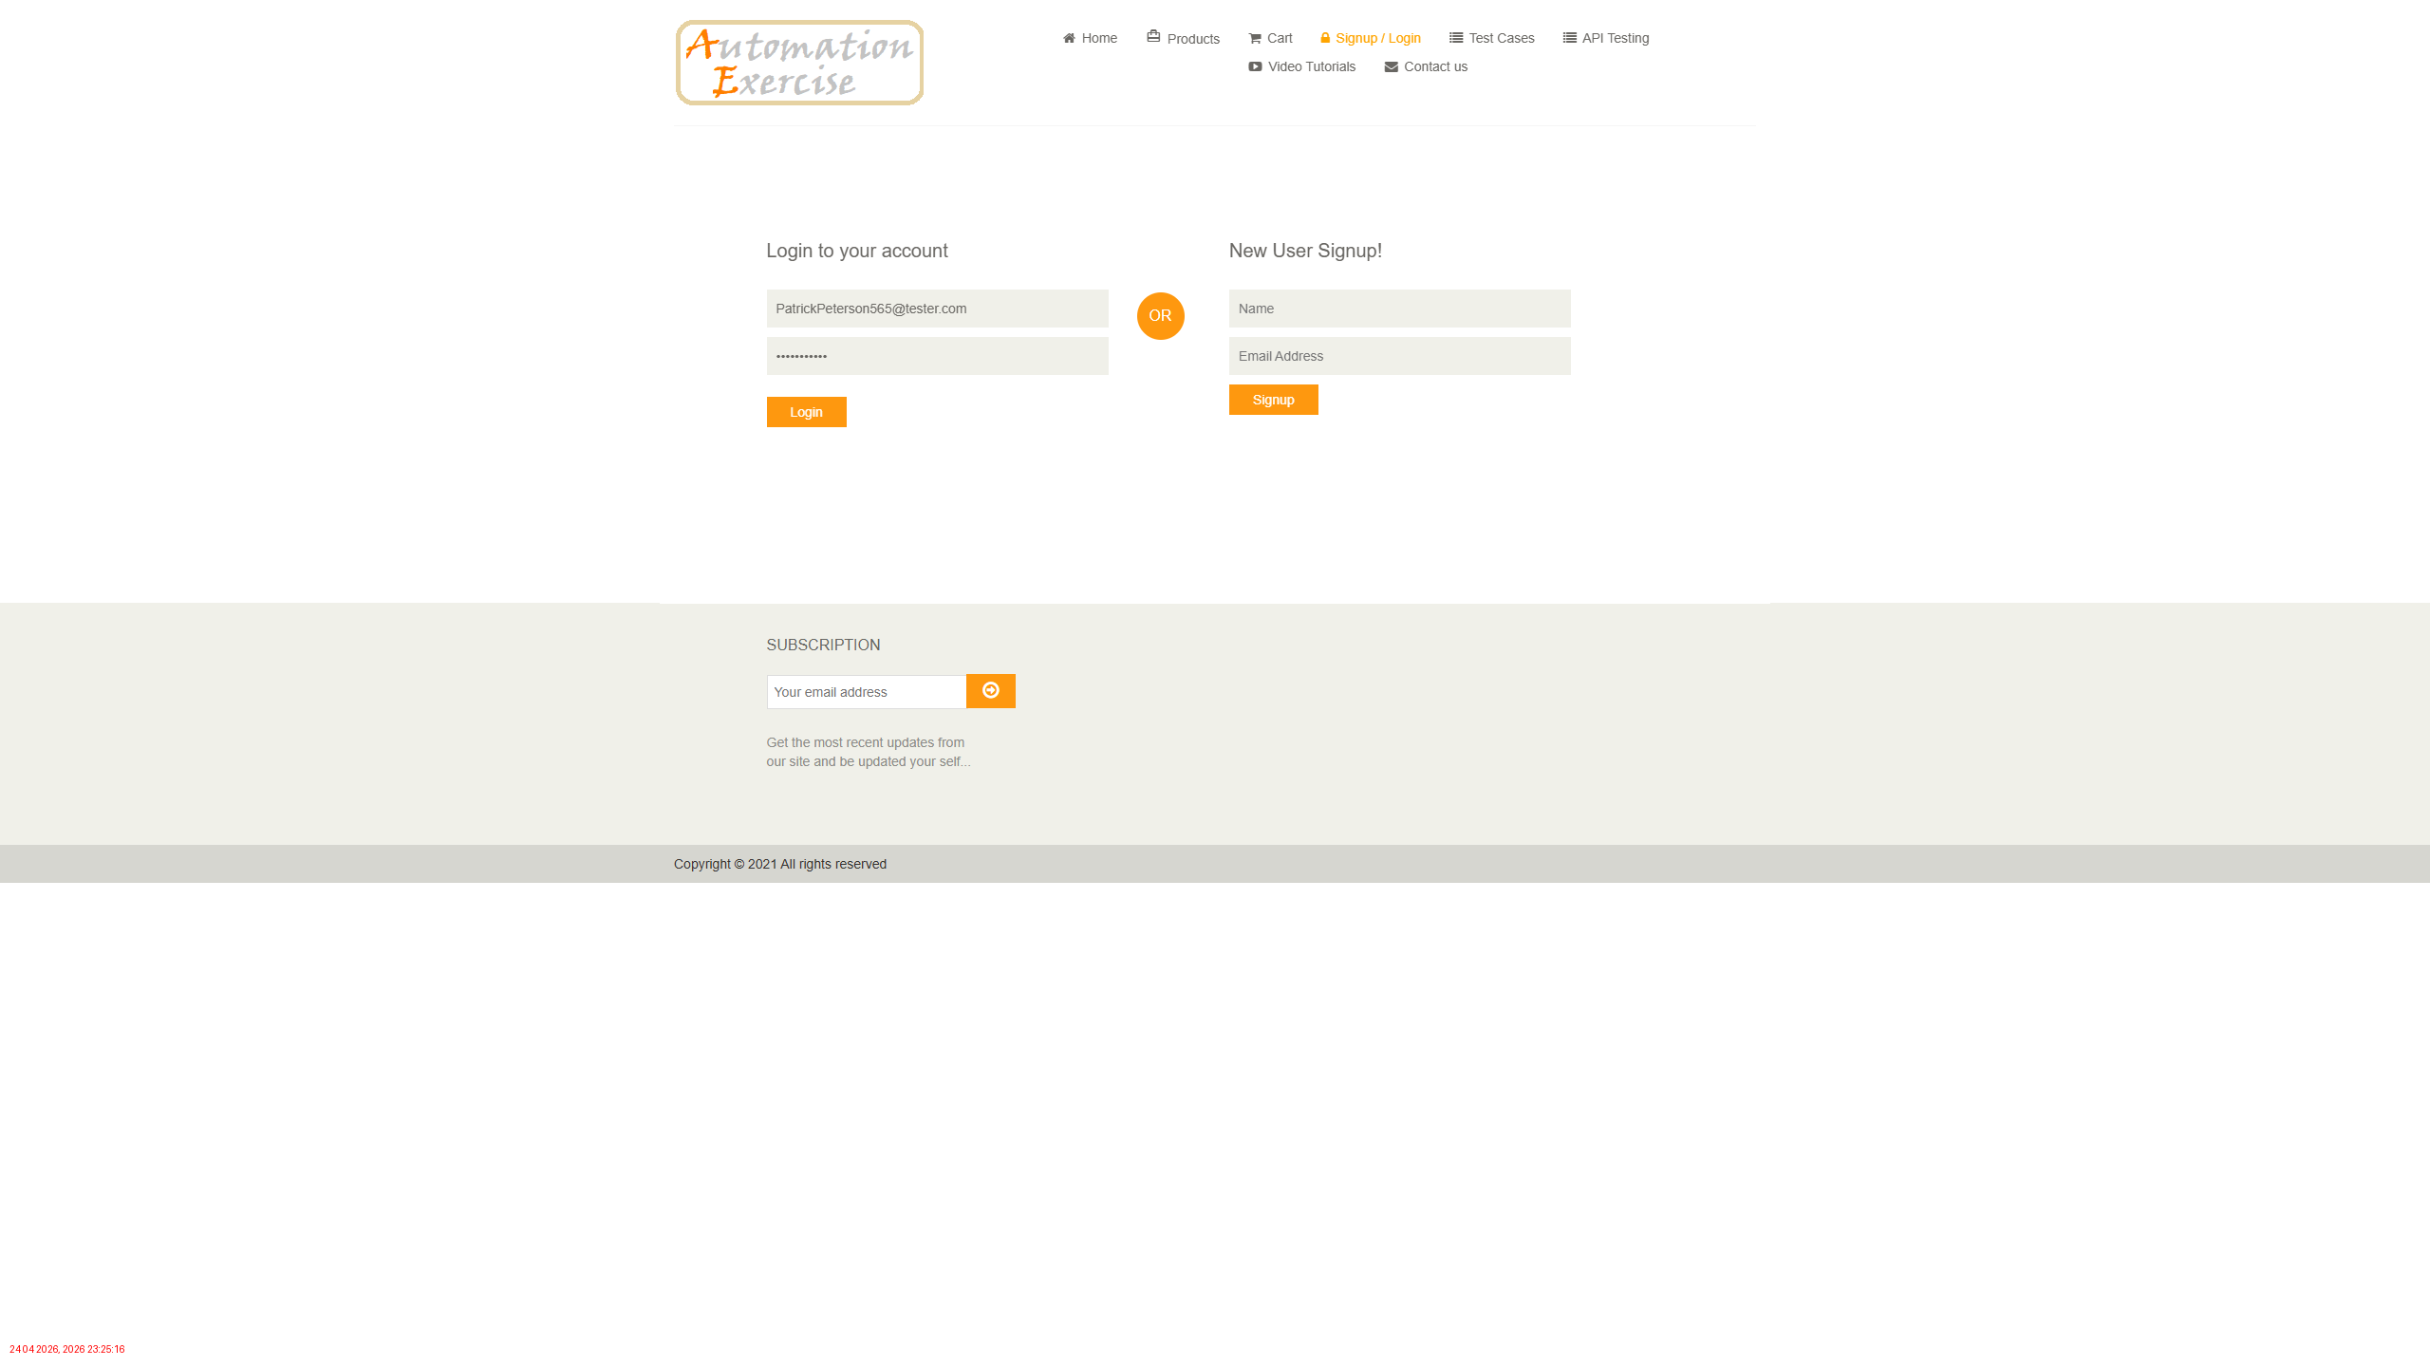
Logged in as Peterson
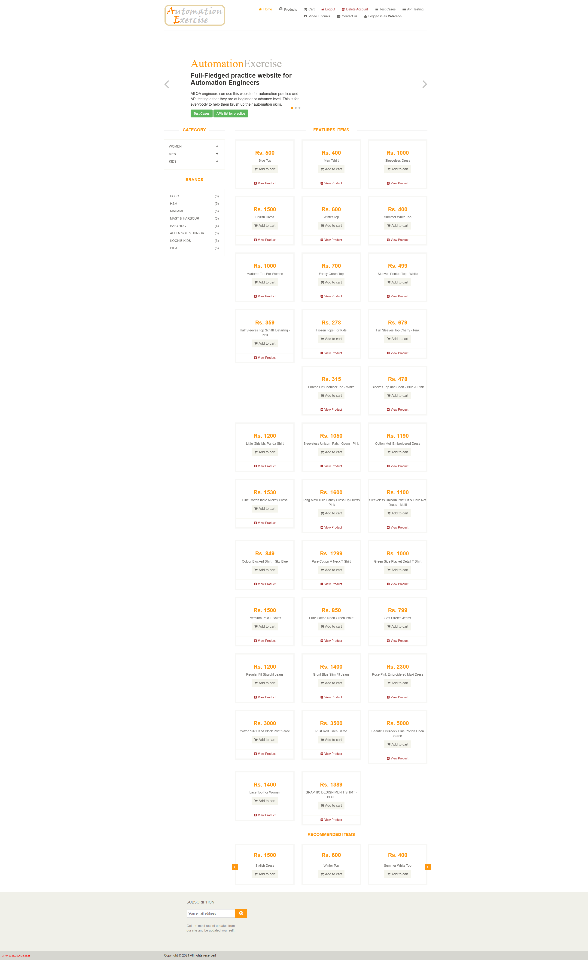

Account Deletion
Account Deleted
